**Table of Contents**

1. Import the dataset and do usual exploratory analysis steps like checking the structure & characteristics of the dataset 2

1. Data type of columns in a table 2

2. Time period for which the data is given 2

3. Cities and States of customers ordered during the given period 2

2. In-depth Exploration: 3

1. Is there a growing trend on e-commerce in Brazil? How can we describe a complete scenario? Can we see some seasonality with peaks at specific months? 3

2. What time do Brazilian customers tend to buy (Dawn, Morning, Afternoon or Night)? 4

3. Evolution of E-commerce orders in the Brazil region: 5

1. Get month on month orders by states 5

2. Distribution of customers across the states in Brazil 5

4.Impact on Economy: Analyze the money movement by e-commerce by looking at order prices, freight and others. 6

1. Get % increase in cost of orders from 2017 to 2018 (include months between Jan to Aug only) - You can use “payment_value” column in payments table 6

2. Mean & Sum of price and freight value by customer state 6

5. Analysis on sales, freight and delivery time 7

1. Calculate days between purchasing, delivering and estimated delivery 7

2. Find time_to_delivery & diff_estimated_delivery. Formula for the same given below: 7

a) time_to_delivery = order_purchase_timestamp-order_delivered_customer_date 7

b) diff_estimated_delivery = order_estimated_delivery_date-order_delivered_customer_date 7

3. Group data by state, take mean of freight_value, time_to_delivery, diff_estimated_delivery 8

4. Sort the data to get the following: 8

a) Top 5 states with highest/lowest average freight value - sort in desc/asc limit 5 8

b) Top 5 states with highest/lowest average time to delivery 9

c) Top 5 states where delivery is really fast/ not so fast compared to estimated date 9

6. Payment type analysis: 10

1. Month over Month count of orders for different payment types 10

2. Count of orders based on the no. of payment installments 10

# 1. Import the dataset and do usual exploratory analysis steps like checking the structure & characteristics of the dataset

select * from `target-project-373409.Target.customers` limit 10

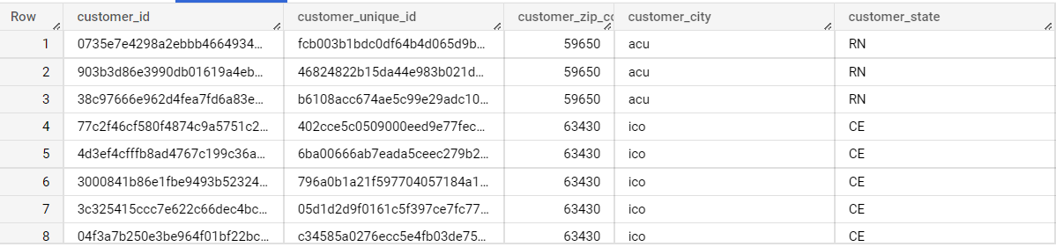

select count(*) from `target-project-373409.Target.customers`

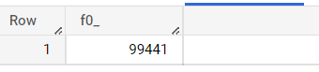

## 1. Data type of columns in a table

Describe `target-project-373409.Target.customers`

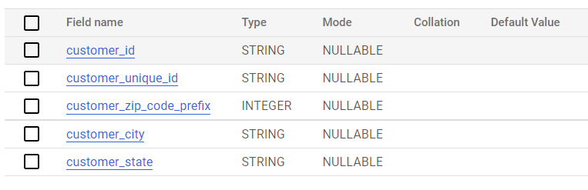

## 2. Time period for which the data is given

SELECT min(order_purchase_timestamp) as start_date, max(order_purchase_timestamp) end_date FROM `target-project-373409.Target.orders`

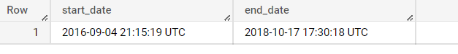

## 3. Cities and States of customers ordered during the given period

SELECT

c.customer_city,c.customer_state

FROM

  `target-project-373409.Target.orders`o

join

`target-project-373409.Target.customers`c

on o.customer_id = c.customer_id

where o.order_purchase_timestamp between '2016-09-04 21:15:19'

and

'2018-10-17 17:30:18';

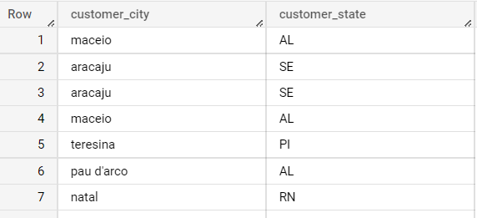

# 2. In-depth Exploration:

## Is there a growing trend on e-commerce in Brazil? How can we describe a complete scenario? Can we see some seasonality with peaks at specific months?

SELECT

  COUNT(*) order_count,

  EXTRACT(year

  FROM order_delivered_customer_date) year ,

  EXTRACT(month

  FROM

    order_delivered_customer_date) month

FROM

  `target-project-373409.Target.orders`

WHERE

  order_status = 'delivered'

GROUP BY

  EXTRACT(year

  FROM

    order_delivered_customer_date) , EXTRACT(month

  FROM

    order_delivered_customer_date)

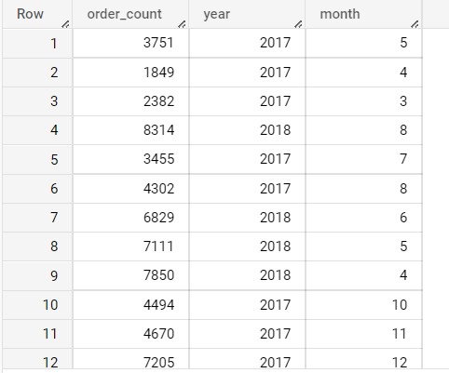

SELECT

  COUNT(*) order_count,

  EXTRACT(month

  FROM

    order_delivered_customer_date) as month

FROM

  `target-project-373409.Target.orders`

WHERE

  order_status = 'delivered'

GROUP BY EXTRACT(month

  FROM

    order_delivered_customer_date)

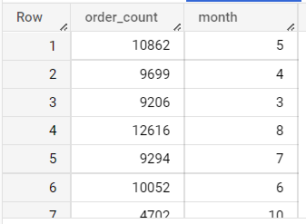

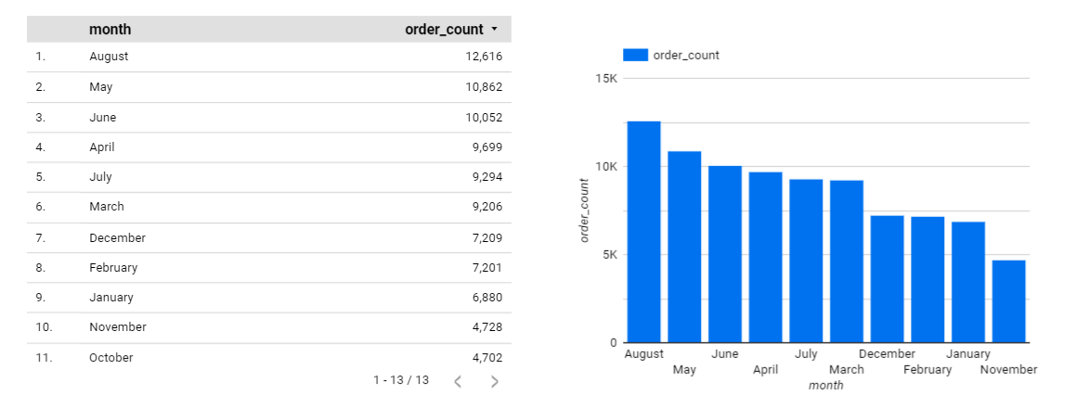

August month has highest orders

SELECT

  COUNT(*) order_count,

  EXTRACT(year

  FROM

    order_delivered_customer_date) as year

FROM

  `target-project-373409.Target.orders`

WHERE

  order_status = 'delivered'

GROUP BY EXTRACT(year

  FROM

    order_delivered_customer_date)

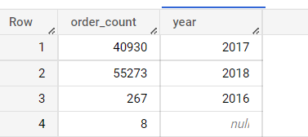

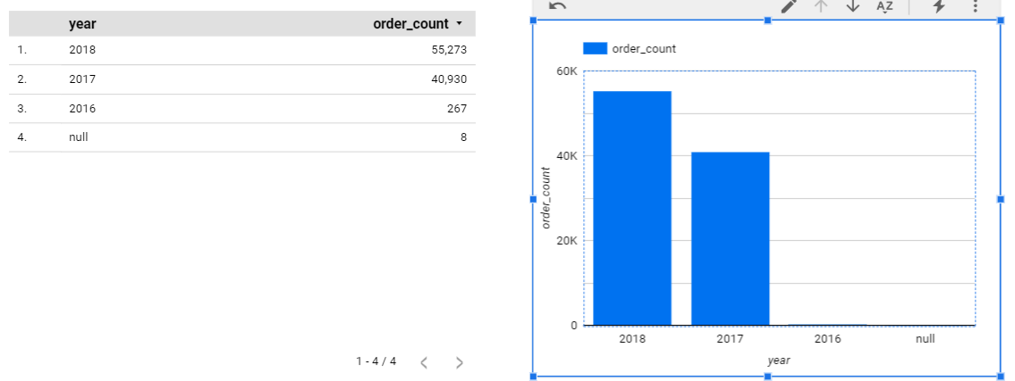

Order Is gradually increasing over the year

## What time do Brazilian customers tend to buy (Dawn, Morning, Afternoon or Night)?

with data as (

SELECT

  COUNT(*) order_count,

extract(hour from order_purchase_timestamp ) as time_of_purchase

FROM

  `target-project-373409.Target.orders`

  group by extract(hour from order_purchase_timestamp )),

  period as

  (select data.*,

  case when time_of_purchase between 0 and 5 then 'dawn'

   when time_of_purchase between 6 and 11 then 'morning'

  when time_of_purchase between 12 and 17 then 'afternoon'

 when time_of_purchase between 18 and 23 then 'night'

   end as period from data)

   select *  from period  ;

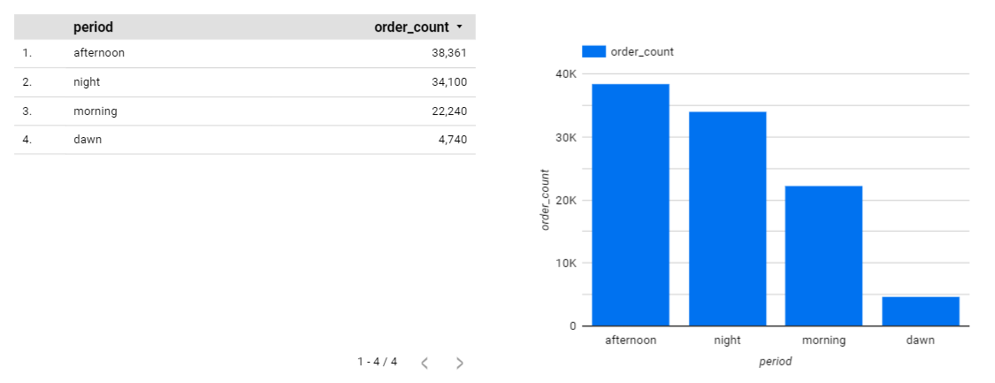

# 3. Evolution of E-commerce orders in the Brazil region:

## Get month on month orders by states

SELECT c.customer_state,extract(year from order_purchase_timestamp) year ,extract(month from order_purchase_timestamp) month

,count(o.order_id)count_order

FROM `target-project-373409.Target.customers`c

join `target-project-373409.Target.orders` o

on c.customer_id = o.customer_id

group by c.customer_state,extract(year from order_purchase_timestamp),

extract(month from order_purchase_timestamp)

order by c.customer_state,extract(year from order_purchase_timestamp)  ,extract(month from order_purchase_timestamp)

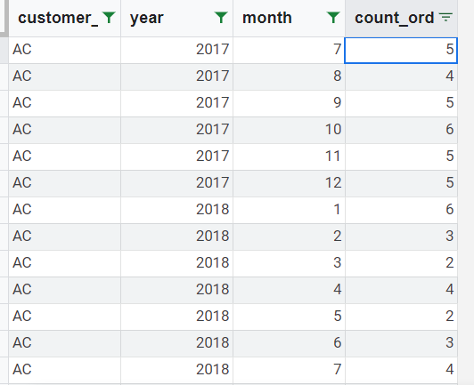

## Distribution of customers across the states in Brazil

SELECT customer_state

,count(customer_id)count_customers

FROM `target-project-373409.Target.customers`

group by customer_state

order by count_customers desc

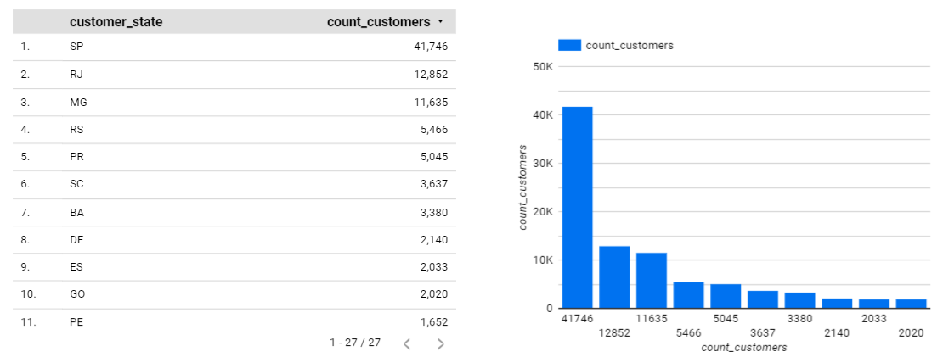

# 4.Impact on Economy: Analyze the money movement by e-commerce by looking at order prices, freight and others.

## 1. Get % increase in cost of orders from 2017 to 2018 (include months between Jan to Aug only) - You can use “payment_value” column in payments table

SELECT

  EXTRACT(year FROM order_purchase_timestamp) year,

  EXTRACT(month FROM order_purchase_timestamp) month,

  SUM(payment_value) total_cost,

  CASE WHEN LAG(SUM(payment_value)) OVER (PARTITION BY EXTRACT(year FROM order_purchase_timestamp) ORDER BY EXTRACT(month FROM order_purchase_timestamp)) = 0 THEN 0

    ELSE

  (SUM(payment_value) - LAG(SUM(payment_value)) OVER (PARTITION BY EXTRACT(year FROM order_purchase_timestamp) ORDER BY EXTRACT(month FROM order_purchase_timestamp))) / LAG(SUM(payment_value)) OVER (PARTITION BY EXTRACT(year FROM order_purchase_timestamp) ORDER BY EXTRACT(month FROM order_purchase_timestamp)) * 100 END percentage_increase

FROM `target-project-373409.Target.payments`p join `target-project-373409.Target.orders` o on p.order_id = o.order_id

WHERE EXTRACT(year FROM order_purchase_timestamp) IN (2017, 2018)

AND EXTRACT(month FROM order_purchase_timestamp) BETWEEN 1 AND 8

GROUP BY EXTRACT(year FROM order_purchase_timestamp),EXTRACT(month FROM order_purchase_timestamp), order_purchase_timestamp

ORDER BY year ASC, month ASC;

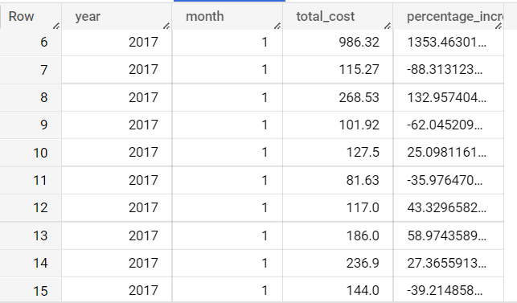

## 2. Mean & Sum of price and freight value by customer state

SELECT sum(freight_value) sum_freight,

avg(freight_value) mean_freight,

sum(price) sum_price, avg(price) mean_price FROM `target-project-373409.Target.order_items` oi  join `target-project-373409.Target.orders` o on oi.order_id = o.order_id join `target-project-373409.Target.customers`c on c.customer_id = o.customer_id

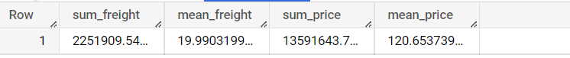

# 5. Analysis on sales, freight and delivery time

## Calculate days between purchasing, delivering and estimated delivery

SELECT  order_id, date_diff(order_estimated_delivery_date, order_purchase_timestamp, day) purchase_estimated_delivery_diff, date_diff(order_delivered_customer_date, order_purchase_timestamp, day) purchase_delivery_diff FROM `target-project-373409.Target.order` order by order_id

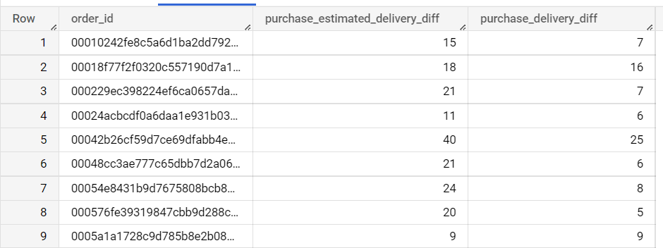

## Find time_to_delivery & diff_estimated_delivery. Formula for the same given below:

## time_to_delivery = order_purchase_timestamp-order_delivered_customer_date

SELECT  order_id, date_diff(order_delivered_customer_date, order_purchase_timestamp, day) time_to_delivery , date_diff(order_estimated_delivery_date, order_delivered_customer_date, day) diff_estimated_delivery FROM `target-project-373409.Target.order` order by order_id

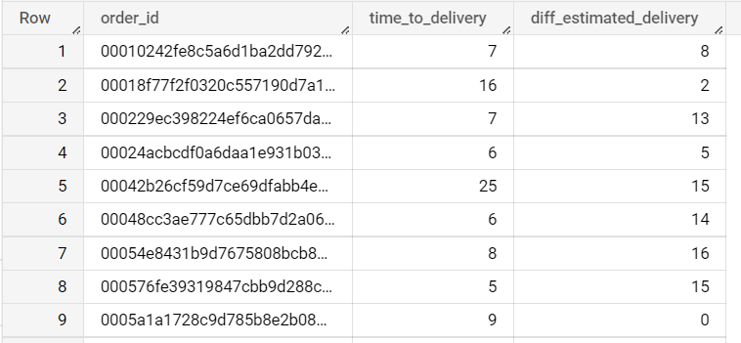

## diff_estimated_delivery = order_estimated_delivery_date-order_delivered_customer_date

SELECT  order_id, date_diff(order_delivered_customer_date, order_purchase_timestamp, day) time_to_delivery , date_diff(order_estimated_delivery_date, order_delivered_customer_date, day) diff_estimated_delivery FROM `target-project-373409.Target.order` order by order_id



## Group data by state, take mean of freight_value, time_to_delivery, diff_estimated_delivery

select

customer_state, avg(freight_value) mean_freight,avg(date_diff(order_delivered_customer_date, order_purchase_timestamp, day)) mean_time_to_delivery ,avg(date_diff(order_estimated_delivery_date, order_delivered_customer_date, day)) mean_diff_estimated_delivery

 FROM `target-project-373409.Target.order_items` oi  join `target-project-373409.Target.orders` o on oi.order_id = o.order_id join `target-project-373409.Target.customers`c on c.customer_id = o.customer_id group by customer_state

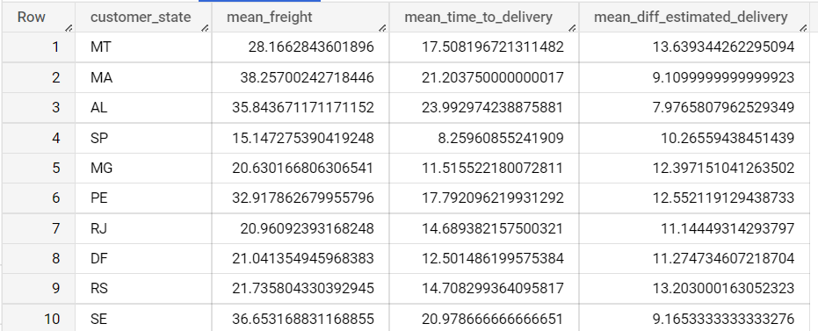

## Sort the data to get the following:

## Top 5 states with highest/lowest average freight value - sort in desc/asc limit 5

select

customer_state, avg(freight_value) mean_freight

 FROM `target-project-373409.Target.order_items` oi  join `target-project-373409.Target.orders` o on oi.order_id = o.order_id join `target-project-373409.Target.customers`c on c.customer_id = o.customer_id group by customer_state order by mean_freight limit 5

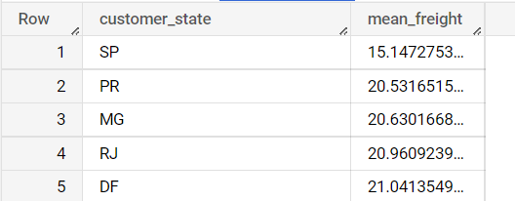

select

customer_state, avg(freight_value) mean_freight

 FROM `target-project-373409.Target.order_items` oi  join `target-project-373409.Target.orders` o on oi.order_id = o.order_id join `target-project-373409.Target.customers`c on c.customer_id = o.customer_id group by customer_state order by mean_freight desc limit 5

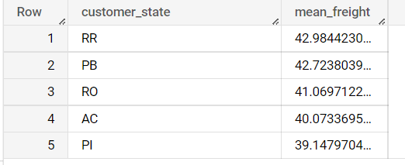

## Top 5 states with highest/lowest average time to delivery

select

customer_state, avg(date_diff(order_delivered_customer_date, order_purchase_timestamp, day)) time_to_delivery

 FROM `target-project-373409.Target.order_items` oi  join `target-project-373409.Target.orders` o on oi.order_id = o.order_id join `target-project-373409.Target.customers`c on c.customer_id = o.customer_id group by customer_state order by time_to_delivery desc limit 5

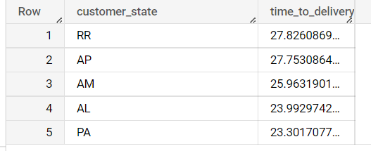

select

customer_state, avg(date_diff(order_delivered_customer_date, order_purchase_timestamp, day)) time_to_delivery

 FROM `target-project-373409.Target.order_items` oi  join `target-project-373409.Target.orders` o on oi.order_id = o.order_id join `target-project-373409.Target.customers`c on c.customer_id = o.customer_id group by customer_state order by time_to_delivery limit 5

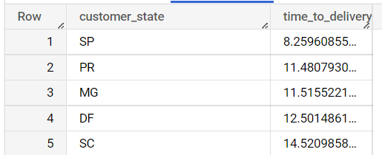

## Top 5 states where delivery is really fast/ not so fast compared to estimated date

select

customer_state, avg(date_diff(order_estimated_delivery_date, order_delivered_customer_date, day) )avg_diff_estimated_delivery

 FROM `target-project-373409.Target.order_items` oi  join `target-project-373409.Target.orders` o on oi.order_id = o.order_id join `target-project-373409.Target.customers`c on c.customer_id = o.customer_id group by customer_state order by avg_diff_estimated_delivery  limit 5

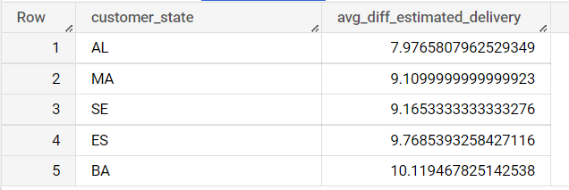

select

customer_state, avg(date_diff(order_estimated_delivery_date, order_delivered_customer_date, day) )avg_diff_estimated_delivery

 FROM `target-project-373409.Target.order_items` oi  join `target-project-373409.Target.orders` o on oi.order_id = o.order_id join `target-project-373409.Target.customers`c on c.customer_id = o.customer_id group by customer_state order by avg_diff_estimated_delivery desc limit 5

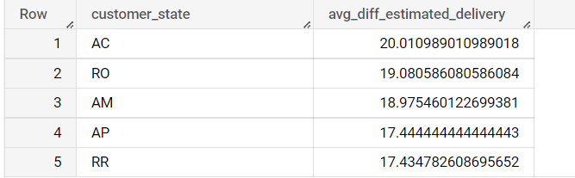

# 6. Payment type analysis:

## Month over Month count of orders for different payment types

SELECT

  EXTRACT(month FROM o.order_purchase_timestamp) month,

  EXTRACT(year FROM o.order_purchase_timestamp) year,

  p.payment_type payment_type,

  COUNT(*) order_count

FROM `target-project-373409.Target.payments` as p  join `target-project-373409.Target.orders` as o on p.order_id = o.order_id

GROUP BY

  EXTRACT(month FROM o.order_purchase_timestamp),

  EXTRACT(year FROM o.order_purchase_timestamp),

  p.payment_type

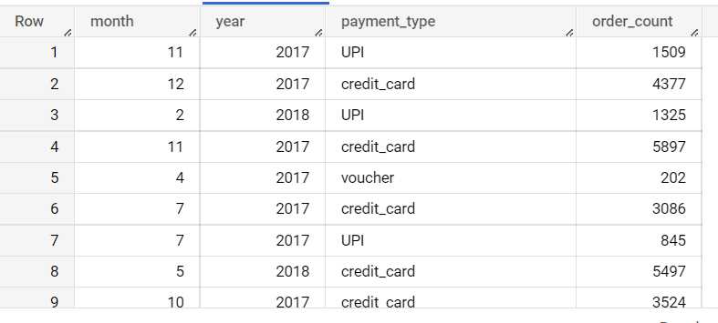

## Count of orders based on the no. of payment installments

SELECT

 p.payment_installments,

  COUNT(*) order_count

FROM `target-project-373409.Target.payments` as p  join `target-project-373409.Target.orders` as o on p.order_id = o.order_id

group by payment_installments

order by payment_installments

